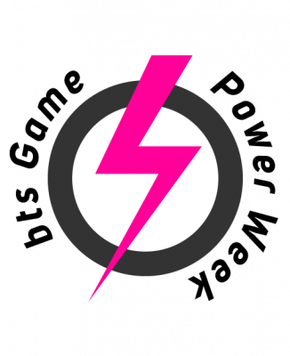

GOPRO Power Week 2019

Geography based Serious Game

Nogueira Alex, Paul Bichler, Jeff Cigrand, Marc Gobbo & Hermann Fuchs | 11.02.2019

# Game Idea

The basic idea of the Game is to have a Party Game on a Board which represents Luxembourg (as a country). You need to race other Players to a specific point in order to claim something like the Star in Mario Party. After every Player took his turn a minigame starts and all the Players have to participate in this minigame. Winning the minigame gives you bonuses on the Board.

# Mechanics

There are three “Phases” :

1.The Player Is rolling a dice for his turn.

2.The Player is interacting with the Board effects.

3.The Player is participating in a minigame.

While in the Board phase, Players may only roll a dice and then if they trigger some specific event they may interact with that event accordingly. (example : a Police officer asks you if you know the name of the city you’re about to enter, and if you don’t know it then you are not allowed to enter it and need to take a detour).

While in the minigame phase, players have to interact with the game according to the minigame Mechanics.

# Minigames

Trivia :

Description

Simple trivia about Luxembourgish Geography.

Controls

Simple up-down selection and A to accept.

### Scatter :

Important architectures/monuments are scattered at the wrong places in Luxembourg and you need to take them to the right place.

### Controls :

Left analog stick to move. A to lay the item down at the place you’re standing at.